
- Survival
UNIT

The Past

Copyright 2015 Cengage Learning. All Rights Reserved. May not be copied, scanned, or duplicated, in whole or in part. Due to electronic rights, some third party content may be suppressed from the eBook and/or eChapter(s).
24 THE PAST
Editorial review has deemed that any suppressed content does not materially affect the overall learning experience. Cengage Learning reserves the right to remove additional content at any time if subsequent rights restrictions require it.

The Parthenon, Acropolis, Athens, Greece

Lesson 1
page 26
Simple Past
Lesson 2
page 33
Past Progressive and Simple Past
Lesson 3
page 39
Past Time Clauses
Lesson 4
page 46
Repeated Past Actions: Used To and Would
Review the Grammar
page 53
Connect the Grammar to Writing
page 56 25


Copyright 2015 Cengage Learning. All Rights Reserved. May not be copied, scanned, or duplicated, in whole or in part. Due to electronic rights, some third party content may be suppressed from the eBook and/or eChapter(s).
Editorial review has deemed that any suppressed content does not materially affect the overall learning experience. Cengage Learning reserves the right to remove additional content at any time if subsequent rights restrictions require it.

Simple Past
LESSON 1

EXPLORE

CD1-08

1 READ the article about a project to protect lions in Kenya. Notice the words in bold.

The Lion Guardians Project, Kenya
Cattle1 are basic to the lives of the Maasai people of Kenya. In fact, the Maasai have a saying, “Without the land and the cattle, there are no Maasai people.” In 2006, Maasai cattle herders2 in Kenya had a problem. Lions regularly killed their cows. The herders sent warriors3 to hunt and kill the lions. Many lions died. The Maasai were a big threat to the survival of lions in Kenya.

A local organization, Living with Lions, wanted to save lions. They helped train Maasai warriors to protect
lions, not kill them. The warriors learned to track the lions with modern technology. They warned herders before the lions got near their cows. The warriors didn’t kill any more lions. Instead, they became Lion
Guardians.4
The Guardians persuaded the herders not to hunt the lions. They gave each lion a Maasai name, and taught the herders and villagers about them.
Local people began to see the lions as individuals. Now, there are more than 30 Lion Guardians. Because of the Guardians’ work, the number of lions that die in their part of Kenya is falling fast.

A lion in the Maasai Mara Game Reserve, Kenya

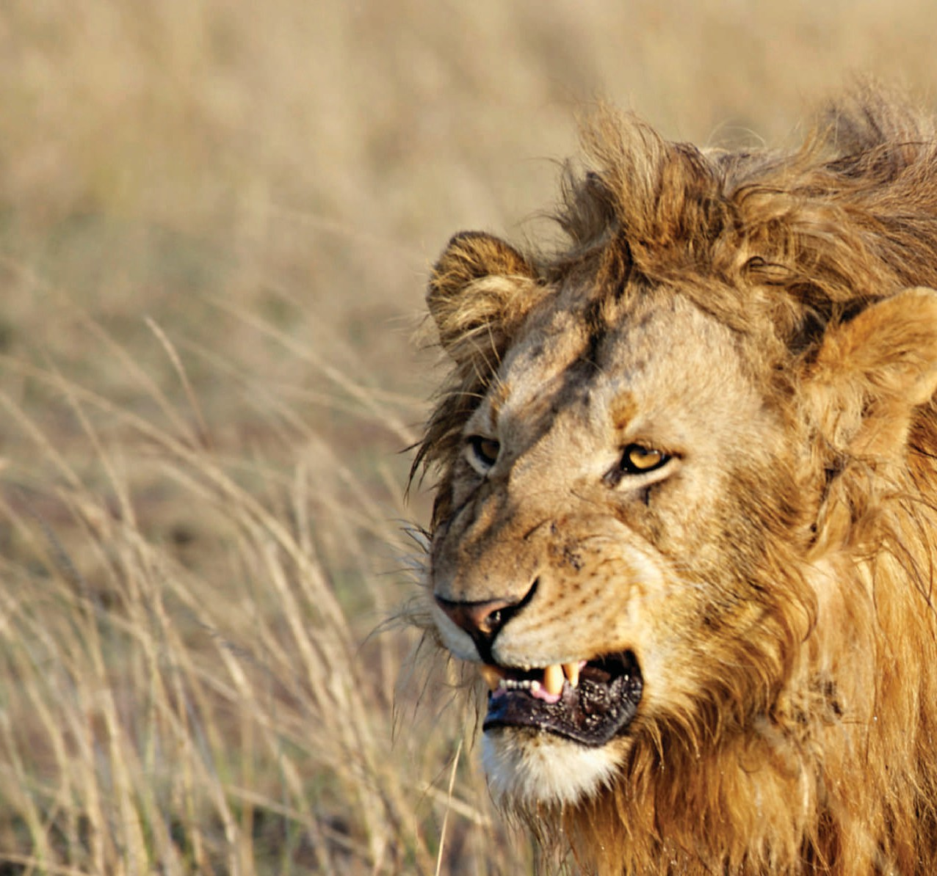






























1 cattle: cows and bulls
2 herder: a person who cares for a large group of one kind of animal
3 warrior: a fighter or soldier
4 guardian: a person who protects other people or property

26 THE PAST
Copyright 2015 Cengage Learning. All Rights Reserved. May not be copied, scanned, or duplicated, in whole or in part. Due to electronic rights, some third party content may be suppressed from the eBook and/or eChapter(s).
Editorial review has deemed that any suppressed content does not materially affect the overall learning experience. Cengage Learning reserves the right to remove additional content at any time if subsequent rights restrictions require it.




2 CHECK. Read the statements. Circle T for true or F for false.
1. Cattle are not important to the Maasai people. | T |   F
2. The Living with Lions organization wanted to protect the lions. | T | F
3. Cattle herders educated Maasai warriors about lions. | T | F
4. Lion Guardians use technology to protect cattle. | T | F
5. Local people learned more about lions from the Lion Guardians. | T | F

- DISCOVER. Complete the exercises to learn about the grammar in this lesson.
  - Find the simple past form of these verbs in the article from exercise 1. Then write them in the charts.
Group A
Present | Simple Past
kill die want learn  persuade | killed

Group B
Present | Simple Past
have send get become teach | had

  - Look at the simple past forms of the verbs in Group A. Compare them with the verbs in Group B. How are they different? Discuss your answer with your classmates and teacher.

A Maasai man uses a cell phone to help guard his cattle.

UNIT 2 LESSON 1 27
Copyright 2015 Cengage Learning. All Rights Reserved. May not be copied, scanned, or duplicated, in whole or in part. Due to electronic rights, some third party content may be suppressed from the eBook and/or eChapter(s).
Editorial review has deemed that any suppressed content does not materially affect the overall learning experience. Cengage Learning reserves the right to remove additional content at any time if subsequent rights restrictions require it.

LEARN

Simple Past: Affirmative and Negative Statements
help them.
go to China.
You/We/They went to Africa. You/We/They didn’t
did not
helped the animals. I/He/She
I/He/She
Negative
Affirmative
Did Not/ Base
Didn’t Form
Subject
Verb
Subject

- Use the simple past for:  - a completed action or event  - a regular or repeated action or event in the past  - past states or feelings | - She called me yesterday.  - I worked every day last week.  - He felt sick this morning.
2. To form the simple past, add -ed or -d to the base form of most regular verbs.1 | play ➔ played dance ➔ danced
3. Be careful! Many common verbs have irregular | eat ➔ ate
past forms.2 | make ➔ made
 | go ➔ went
 | see ➔ saw
4. The simple past forms of be are was and were.  Do not use did not or didn’t with was and were in the negative. | It was warm. It wasn’t cold.  They were at work. They weren’t at home.
- I wasn’t late for class yesterday.
✗ I didn’t was late for class yesterday.

1 See page A2 for spelling rules for the simple past.
2 See page A4 for a list of irregular verbs.

- Complete each sentence with the simple past form of the verb(s) in parentheses.
- Herders in Kenya weren’t (not be) able to protect their cattle.

- For years, lions (kill) many cows in Kenya.

- The herders (send) warriors to hunt the lions.

- Living with Lions (start) a new program in 2007.

- At first, some Maasai (not be) happy about the program.

- The organization (give) every Guardian a cell phone.

- When a Lion Guardian (see) a lion nearby, he (call) his neighbor.
- The Lion Guardians project (not change) the situation in Kenya immediately. It (take) time.
- Scientists (study) the lion population.

- The Lion Guardians (not save) all the lions.

28 THE PAST

Simple Past: Questions and Answers
Yes/No Questions
Short Answers
Did
we/you/they
help?
Yes, she did. / No, she didn’t.
Yes, they did. / No, they didn’t.
Wh- Questions
Short Answers
This morning.
Because she had a meeting. Nick and Sarah.
Who or What as Subject
Short Answers
Who
What
called?
happened?
My sister.
I missed the train.
- Whom is sometimes used as the object in very formal speaking or writing.
- Remember: Who or What can take the place of the subject in a Wh- question. When Who or What is the subject, do not use did.
Whom did you ask?
- Who called?
✗ Who did call?
Verb
Wh- Word
Base Form
Did Subject
I/he/she/it

Wh- Word | Did | Subject | Base Form
When | did | you | call?
Why |  | she | leave?
Who(m) |  | they | see?

- Complete the short conversations with the words in parentheses. Write simple past questions and then write the answers.
- A: Did your phone ring (your phone / ring) just now? B: Yes, it did .
- A: (your parents / give) you any money last month?
B: No, .

- A: (the teacher / send) you an e-mail? B: No, .
- A: (your friend / pay) for your lunch yesterday? B: Yes, .
- A:
REAL ENGLISH
Time expressions such as last night, last week, six months ago, or in 2011 are often used with the simple past.
I saw Kim two days ago.
She swam every day last year.
(you / do ) anything fun last night?
B: No, .

- A:
(I / disturb) you?
B: No, .

UNIT 2 LESSON 1 29

- A: (it / rain) yesterday? B: Yes, .
- A: (we / have) homework last night? B: Yes, .

- SPEAK. Work with a partner. Take turns asking and answering the questions from exercise 5. Use your own answers, not the answers in the book.

- Complete the conversations. Use the words in parentheses to write simple past questions.
- A: Why did you go (you / go) to Kenya? B: Because we wanted to see the wildlife there.
- A. How often (you / see) lions when you were in Kenya?
B: Almost every day.

- A: Who (the camera / belong to)? B: It belonged to our guide.
- A. (Katya / write) in her journal last night? B: Yes, she did.
- A. Who (give) the presentation yesterday? B: Sheila.
- A. When (the plane / arrive)? B: A few minutes ago.

PRACTICE
- Complete the conversation with the words in parentheses. Use the simple past.
Amy: (1) Did you read (you / read) Jinny’s e-mail about the whale rescue?
Josh: No, I didn’t. (2) (what / she / say)?
Amy: Well, the whale (3) (come) too close to the shore, and some fishermen (4) (find) it in their net.
Josh: That’s terrible! (5) (it / survive)?
Amy: Yeah, it did, but according to Jinny, the rescue (6) (take) about an hour.
Josh: So, (7) (she / take) any photos of it?
Amy: Yes, (8) (she / take) a lot. (9) (she / send) a few of them with her e-mail. They’re amazing!

30 THE PAST

LISTEN & WRITE.
Emperor penguins crowd together to keep warm.


CD1-09


CD1-09
- Listen to an interview with a nature filmmaker. Then complete the questions from the interview with the verbs in parentheses. Use the simple past.
  - How long did it take (it / take) to make your last nature film?

  - Why (you / choose) Antarctica?

  - So, what (you / see)?

  - Why (they / walk) so far?

  - When (the females / return)?

- Listen again and check your answers.

- Read the summary of the last part of the interview. Then complete the paragraph with the verbs in the box. Use the simple past.

begin climb come crowd fall keep lay return survive walk
The emperor penguins (1) climbed onto the sea ice and
(2) 50 miles to mainland Antarctica. The females each (3) one egg and (4) to the sea. The males (5) the eggs safe through the terrible winter. They (6) together to keep warm. The temperature

(7) to –40 degrees Fahrenheit, but the males (8) . In the spring, the females (9) back. Then the sea ice (10) to melt.

CD1-09
- Work with a partner. Compare your answers from exercise C. Then listen again and check your answers.

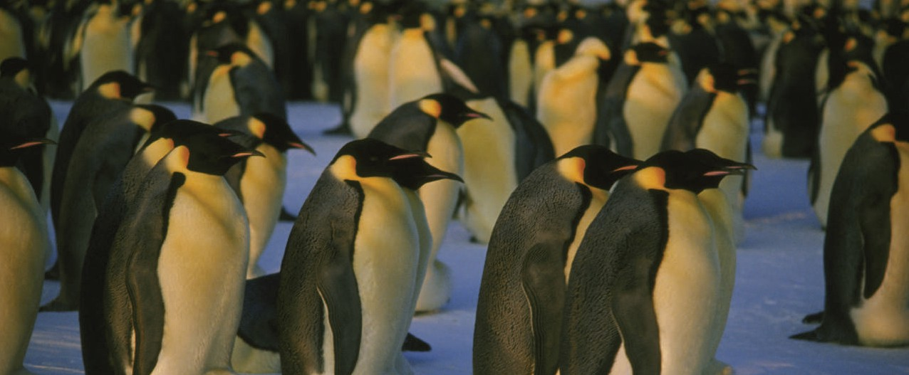
UNIT 2 LESSON 1 31

- EDIT. Read the conversation. Find and correct seven more errors with the simple past.

Rolf: Hi, Jun. Did you finished your assignment about animal survival yesterday?
Jun: Hi, Rolf. Yes, I did. I write about giant pandas in China.
Rolf: That’s an interesting choice. How did it go?
Jun: Oh, it didn’t went very well.
Rolf: What did go wrong?
Jun: Well, I did a lot of research, but I didn’t found much new information. Everyone else’s assignments were at least five pages, but my assignment was only two pages.
Rolf: What Professor Blake said?
Jun: She didn’t say anything—she just look at me.
Rolf: Well, don’t worry too much. I gave her the shortest assignment last week and got the highest grade in the class. She sayed it was excellent!

APPLY.
  - Write interview questions to ask a classmate about a recent project or assignment. Use the words in the box to help you.

Did you . . . ? | What did you . . . ? | Where did you . . . ? | Who did you . . . ?
When did you . . . ? | Why did you . . . ? | How did you . . . ?


A giant panda bear
eating bamboo

32 THE PAST
  - Work with a partner. Ask and answer your questions from exercise A. Take notes on your partner’s answers in your notebook.
A: What did you write about? B: I wrote about sports in schools.

  - Write a paragraph of four or five sentences about your partner’s assignment or project.
Alain wrote a paper about sports in schools. He did a lot of research. He asked all his friends for their opinions. He also interviewed the football and baseball coaches.

EXPLORE
Past Progressive and Simple Past
LESSON 2

CD1-10
    - READ a radio interview with a woman who works to help Maya languages survive in Guatemala. Notice the words in bold.
Community Radio in Guatemala
Interviewer: So, Angelica, you work as a volunteer1 at a community2 radio station. Why is that an important job in Guatemala today?
Angelica: When I was growing up, you almost never heard Maya languages on the radio or TV. Some Maya languages were dying. Then, community stations started presenting shows in Maya languages. They help keep the
languages and the culture alive.
Interviewer: Now, let’s go back to when you got the job.
Why did the radio station choose you?
Angelica: I was teaching my local language, Tzuthil. Oh, and I was playing traditional music in a band.
Interviewer: Were they looking for a musician, then?
Angelica: No, not exactly. They were trying to find someone to present a show about Maya music. I was waiting for an opportunity like that.
Interviewer: Is the survival of Maya languages still in danger?
Angelica: Yes, but community radio stations help. They encourage people to preserve Maya languages and culture.

1 volunteer: a person who does work without being paid for it
2 community: a group of people who live in the same area and have common interests

The Maya have lived in Guatemala for thousands of years.




UNIT 2 LESSON 2 33
Copyright 2015 Cengage Learning. All Rights Reserved. May not be copied, scanned, or duplicated, in whole or in part. Due to electronic rights, some third party content may be suppressed from the eBook and/or eChapter(s).
Editorial review has deemed that any suppressed content does not materially affect the overall learning experience. Cengage Learning reserves the right to remove additional content at any time if subsequent rights restrictions require it.

    - CHECK. Choose the correct answer for each question.

      - Why is community radio important in Guatemala?
        - It provides jobs for people.
        - It helps the Maya culture survive.
        - It plays a lot of music.

      - What was Angelica doing when she got her job on the radio?
        - studying her local language
        - traveling around Guatemala
        - playing traditional music
      - Who was the radio station looking for?
        - a presenter
        - a musician
        - a teacher

      - What was happening to some Maya languages before community radio?
        - They were growing.
        - They were changing.
        - They were dying.


Two Guatemalan musicians sit
with their instruments.
34
Copyright 2015 Cengage Learning. All Rights Reserved. May not be copied, scanned, or duplicated, in whole or in part. Due to electronic rights, some third party content may be suppressed from the eBook and/or eChapter(s).
Editorial review has deemed that any suppressed content does not materially affect the overall learning experience. Cengage Learning reserves the right to remove additional content at any time if subsequent rights restrictions require it.

    - DISCOVER. Complete the exercises to learn about the grammar in this lesson.
- Read the pairs of sentences about the interview from exercise 1 and notice the verbs in bold. Choose the sentence in each pair that describes an action that was in progress at a certain time in the past.
  - a. The radio station chose Angelica.
    - Angelica was teaching Tzuthil in the evenings.

  - a. The radio station was looking for a new presenter.
    - They decided to speak to Angelica.

  - a. Several Maya languages were dying.
    - Community radio stations started to present shows in Maya languages.

- Work with a partner. Compare your answers from exercise A. Which verb form is used to describe actions that were in progress at a certain time in the past?

LEARN

Past Progressive: Affirmative and Negative Statements
Subject | Was/ Were | Verb + -ing
I/He/She/It | was | working.
You/We/They | were

Subject | Was Not/ Were Not | Verb + -ing
I/He/She/It | was not wasn’t | sleeping.
You/We/They | were not weren’t

    - Use the past progressive to talk about an action that was in progress at a certain time in the past.
Negative
Affirmative

    - Remember: Use the simple past for completed or repeated past actions, events, states, and feelings.
    - Remember: Non-action verbs are not usually used with the progressive.
were studying
9:00 now
They were studying at 9:00 last night. Yesterday I rode my bike to work.
She swam every day last week.
He didn’t like the movie.
- I saw an accident last night.
✗ I was seeing an accident last night.

See page A1 for spelling rules for the -ing form of verbs.

    - Complete each sentence with the past progressive form of the verb(s) in parentheses.
      - Angelica was teaching (teach) her local language in the evenings.

      - At 6:00 p.m. many people in town (listen) to Angelica’s show.

      - The radio (play) loud dance music last night.

      - We (talk) to Carlos, but he (not listen) to us.
      - Pedro (look) for a job at a radio station, but he didn’t find one.

      - Tom and Karen (live) in Guatemala last year.

      - The people next to us (speak) Spanish. I think they were Mexican.
      - Steve (sit) in the library, but he (not study). He (read) a magazine.
REAL ENGLISH
The past progressive is often used to describe a scene in the past.
The café was full. A band was playing, and people were talking loudly.
Everyone was enjoying the evening.

UNIT 2 LESSON 2 35

    - WRITE & SPEAK. Complete the sentences. Use the past progressive. Make two of your sentences negative. Then share your sentences with a partner.
      - Last night at 9:00, I was having dinner with my friends .
      - At 5:00 this morning .

      - Last August .

      - On Sunday morning .

      - Two years ago .

Past Progressive: Questions and Answers
Yes/No Questions
Short Answers
Yes, she was. / No, she wasn’t.
Yes, they were. / No, they weren’t.
Wh- Questions
Short Answers
He was working.
At the library.
Who or What as Subject
Short Answers
Rita.
My car.

Remember: Who or What can take the A: Who was playing that loud music last night? place of the subject in a Wh- question. B: Alex and Rui.

Was/ Were | Subject | Verb + -ing
Was | I/he/she | listening | to music?
Were | you/we/they | eating | dinner?

Wh- Word | Was/ Were | Subject | Verb + -ing
What | was | he | doing | at 3:00?
Where | were | you | studying | last night?

Wh- Word | Was | Verb + -ing
Who | was | singing | last night?
What | was | making | that noise?

    - Use the words in parentheses to complete the questions and answers. Use the past progressive.
      - A: What was Berta doing (Berta / do) in the evenings? B: She was teaching (she / teach).
      - A: (they / speak) Spanish? B: No, .
      - A: (you / wait) for me? B: Yes, .
      - A: Where (you / go) after class yesterday? B: (I / go) home.

36 THE PAST

      - A: Who (Jane / talk) to?
B: (she / talk) to her math teacher.

      - A: Why (those people / cheer)? B: Because (their team / play) really well.
      - A: What (you / do) at 8:00 last night? B: (I / cook) dinner.
      - A: (it / snow) last night? B: No, .

    - SPEAK. Work with a partner. Take turns asking and answering questions 4, 7, and 8 from exercise 6. Use your own answers, not the answers from the book.
A: Where were you going after class yesterday? B: I was going to the gym.

PRACTICE
    - Circle the correct verb forms to complete each situation.
      - We (1) were listening / listened to a great band last night. They (2) were playing / played three songs, and then they (3) were stopping / stopped. We (4) were wanting / wanted them to play more songs, but they didn’t. We (5) were leaving / left and (6) were asking / asked for our money back.
      - Lily’s watch (7) was breaking / broke yesterday morning. It (8) was falling / fell off her
wrist on her way to work. She (9) was walking / walked out of the subway station at the time, and someone (10) was stepping / stepped on it. Last night after work, she (11) was buying / bought a new one.
      - I (12) was sitting / sat at the student center yesterday afternoon. Several students (13) were studying / studied. Others (14) were using / used their phones. Then I (15) was seeing / saw my friend, Phil. He (16) was eating / ate lunch alone, so (17) I was going / went over and
(18) was sitting / sat with him.

    - Complete each sentence with the past progressive or the simple past form of a verb from the box.
arrive die open own see sleep think walk
      - The language was dying . Only a few people spoke it.

      - I saw street musicians when I home last night.

      - Debbie a nice car, but she didn’t drive it much.
UNIT 2 LESSON 2 37

      - I’m surprised Kumiko is here today. I she was on vacation.

      - Marcia to the meeting 15 minutes late. Her boss was very angry.

      - I Andy yesterday. He was talking to some friends.

      - My sister called me at midnight last night. I , and she woke me up.

      - The professor the door and left the room.

    - EDIT. Read the information about Dr. Gregory Anderson’s work in Siberia. Find and correct five more errors with the simple past and the past progressive.

Dr. Anderson in Siberia
Dr. Anderson and his team made some interesting discoveries during a trip to Siberia in
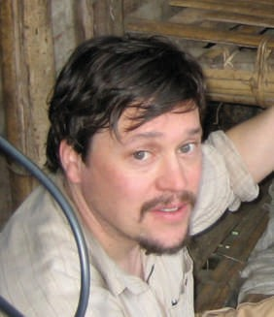


























Russia. They were studying Xyzyl (hizzle), a local

visited
language there. They were visiting five villages
during their trip, and they found that 50 to 60
people in those communities spoke Xyzyl in their daily lives. In one village, they were talking to an eleven-year-old girl called Kristina. She was knowing how to speak Xyzyl. Her grandmother was teaching her. Kristina was the youngest Xyzyl speaker in the village.

Most of the other Xyzyl speakers got old. Many of them were 60 years old or older. It was clear that the Xyzyl language died. Dr. Anderson and his team studied the language, and they were making recordings to help it survive.

APPLY.
- Work with a partner. Write interview questions for Dr. Anderson. Use the information from exercise 10 and the words below to help you. Use the simple past or the past progressive.
  - where / your team go Where did your team go?
  - how many villages / you / visit

  - who / you / talk to in the village

  - what / you / do in the village

  - your idea:

- Role-play a radio interview with Dr. Anderson. Partner A is the interviewer. Partner B is Dr. Anderson. Use your questions from exercise A, the information from exercise 10, and your imagination.

38 THE PAST
A: So, tell us about your trip, Dr. Anderson. Where did your team go?
B: We went to Siberia.

EXPLORE
Past Time Clauses
LESSON 3


CD1-11
- READ the article about Jimmy Chin, a mountain climber and photographer. Notice the words in bold.

Surviving an Avalanche
Jimmy Chin is one of the few people to survive a Class 4 avalanche—an avalanche big enough to destroy buildings. In 2011, while he was skiing in the Teton Mountains,
an avalanche started behind him. Chin was going down the mountain when, in his own words, “the whole mountainside came down.”
The avalanche buried Chin under tons of snow and carried him downhill. Halfway down, the rolling snow threw him to the surface. However, Chin was not safe. When he looked

Jimmy Chin has climbed up and skied down Mount Everest, the world’s highest mountain.
up, trees were snapping all around him. The snow was still moving fast. Soon the avalanche buried him again.

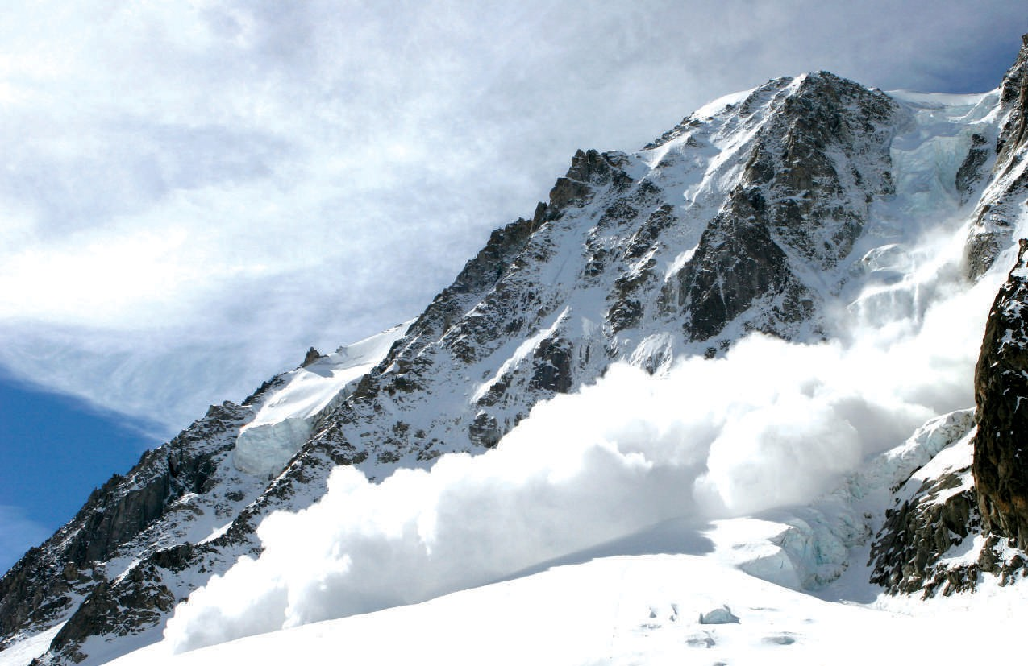
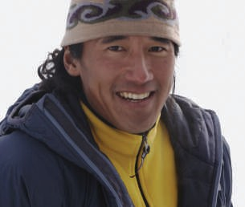
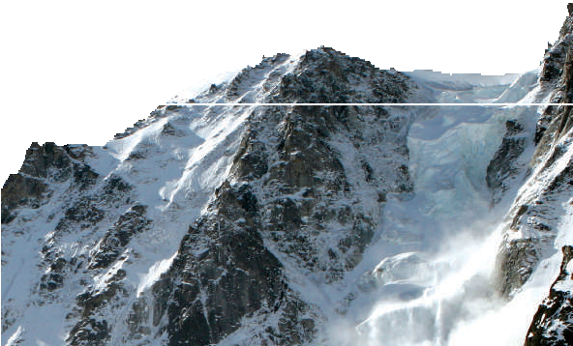
“I knew I was going to the bottom of the valley,” he remembers. Amazingly,1 when the avalanche reached the bottom of the mountain, Chin was pushed to the surface! He was alive and on top of the snow when his very surprised friends reached the bottom of the valley.
After this experience, Chin took a month off from work. “It’s important to do what’s meaningful to you,” he says. “You don’t want to take your time for granted.”2

1 amazingly: (very) surprisingly
2 take something for granted: not be grateful enough for something

An avalanche carries hundreds of tons of snow down a mountain.

UNIT 2 LESSON 3 39
Copyright 2015 Cengage Learning. All Rights Reserved. May not be copied, scanned, or duplicated, in whole or in part. Due to electronic rights, some third party content may be suppressed from the eBook and/or eChapter(s).
Editorial review has deemed that any suppressed content does not materially affect the overall learning experience. Cengage Learning reserves the right to remove additional content at any time if subsequent rights restrictions require it.

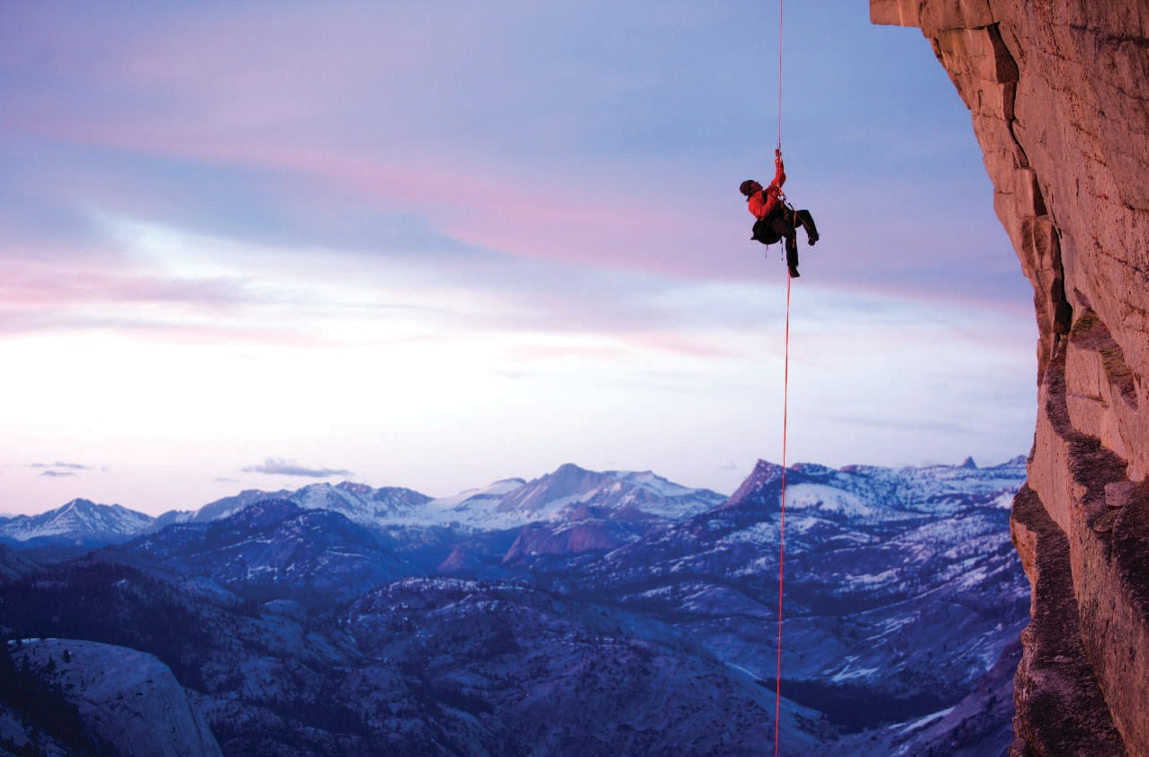
- CHECK. Read the statements. Circle T for true or F for false. Then correct the false statements to make them true.
4

1. A Class 1 avalanche can destroy buildings. | T |   F
2. Jimmy Chin was skiing alone in the Tetons. | T | F
3. The avalanche buried Chin at first. | T | F
4. Chin’s friends had to dig him out of the snow. | T | F
5. Chin decided to take a break after this experience. | T | F

- DISCOVER. Complete the exercises to learn about the grammar in this lesson.
  - Look at the two underlined events in each sentence from the article in exercise 1. Write 1
above the event that started first.
    - In 2011, while he was skiing in the Teton Mountains, an avalanche started behind him.

    - When he looked up, trees were snapping all around him.

  - Circle the correct answer to complete each statement.
    - The simple past / past progressive form is used for the event that starts first.

    - The simple past / past progressive form is used for the event that interrupted another event.

Jimmy Chin climbing in California

40 THE PAST
Copyright 2015 Cengage Learning. All Rights Reserved. May not be copied, scanned, or duplicated, in whole or in part. Due to electronic rights, some third party content may be suppressed from the eBook and/or eChapter(s).
Editorial review has deemed that any suppressed content does not materially affect the overall learning experience. Cengage Learning reserves the right to remove additional content at any time if subsequent rights restrictions require it.

LEARN
  - Past Time Clauses with When and While
When
The storm began when I was driving home.
While
The storm began while we were walking home.
Main Clause Past Time Clause Main Clause Past Time Clause
When I was driving home, the storm began. While we were walking home, the storm began.
Past Time Clause Main Clause Past Time Clause Main Clause
I was sleeping when you texted me. You texted me while I was sleeping.
Main Clause Past Time Clause Main Clause Past Time Clause

1. A clause is a group of words with a subject and a verb. A main clause can stand alone as a complete sentence. | Elena called last night while I was cooking dinner.  Main Clause Past Time Clause
2. A past time clause tells when an action or event happened. A past time clause can come before or after the main clause. | When it started to snow, I was walking home. It started to snow while I was walking home.
3. Use while or when + the past progressive to show that one action was in progress when another action happened. | I broke my leg when I was skiing.  Second Action Action in Progress  Iris called while I was cooking dinner.  Second Action Action in Progress
4. Use when + the simple past for an action or event that happened at a specific point in the past. | I was painting the living room when I fell off the ladder.  Action in Progress Action at a Point in the Past
5. Use a comma when the time clause comes at the beginning of a sentence. | When we were taking the exam, the lights went out. The lights went out when we were taking the exam.

- Circle the correct form of the verb(s) to complete each sentence.
- Jimmy Chin skied / was skiing when the avalanche began / was beginning.

- When Chin’s friends reached / were reaching him, he lay / was lying on top of the snow.

- Terry lost / was losing his watch when he swam / was swimming in the ocean.

- Mark and Dan’s boat sank / was sinking while they fished / were fishing.

- I cut / was cutting my finger when I cooked / was cooking dinner.

- While Jean shopped / was shopping, the fire alarm went off / was going off in the store.

- Carla found / was finding fifty dollars when she walked / was walking home yesterday.

- Andre prepared / was preparing for the party when he suddenly felt / was feeling sick.

- My pencil broke / was breaking while I took / was taking the exam.

- Padma heard / was hearing a strange noise when she hiked / was hiking in the woods yesterday afternoon.

UNIT 2 LESSON 3 41

Past Time Clauses with When: Events in Sequence

1. When two actions happened one after the other, use the simple past in the past time clause and the main clause. Use when to introduce the past time clause. | When her phone rang, she answered it.  Past Time Clause Main Clause
2. The past time clause can come first or second in the sentence. The action or event in the past time clause happened first. | When I got home, I took a shower.  First Event Second Event  I took a shower when I got home.  Second Event First Event
3. Remember: Use a comma when the past time clause comes first in the sentence. | When Joe saw the accident, he called the police.

- Read each sentence. Which action or event happened first? Which action or event happened second? Write 1 for first and 2 for second below each action. Add a comma if necessary.
- When the storm ended the workers began to clean up.
(1)
,
(2)

- When Tuan got out of the hospital he made plans for a vacation.
( ) ( )

- We looked out the window when we heard the noise. ( ) ( )
- When she saw the fire in her kitchen Michelle screamed for help.
( ) ( )

- My son called me when his plane landed. ( ) ( )
- The music started when the bride and groom walked into the room. ( ) ( )
- When the phone rang Isabelle turned the TV off.
( ) ( )

- I called my parents when I received my exam results. ( ) ( )

- Complete each sentence with the correct form of the verb in parentheses.
- Eric finished his assignment when he got (get) home.

- When Vicky (put) her bag on the floor, a thief stole it.

- When Max’s car broke down, he (walk) to the nearest gas station.

- My sister laughed when I (tell) her the joke.

- Juanita smiled when she (hear) the good news.

42 THE PAST

- We (buy) our tickets when we got to the station.

- Sylvie closed the window when it (start) to rain.

- I lit some candles when the electricity (go) out.

- SPEAK. Work with a partner. Complete the sentences.
When I woke up this morning . . . When I woke up this morning, I called my parents.
When I got to class . . .
When I finished my homework . . .















PRACTICE
- Look at the time line about a mine accident in Chile. Then complete each sentence with the simple past or past progressive form of a verb from the box.

0 Aug 5: 33 miners were trapped underground in a mine. (Day 1)
10 Aug 22: Rescuers discovered that all 33 miners were alive. (Day 17)
20 Aug 30: The drills1 started to work. (Day 26)
30
40
DAY
50
Oct 9: One of the drills reached the miners. (Day 66)
60
Oct 13: Rescuers lifted all 33 miners to safety. (Day 69)
70
80 Oct 24: National celebration for the miners in Santiago, Chile (Day 80)

1drill: a machine that makes a round hole
arrive attach begin complete fall read wait watch

- On August 5, 2010, when 33 miners were working in a mine in Chile, the roof
fell and trapped them.

- While the miners’ families anxiously for news, the mining company began its rescue attempts.
- When those attempts failed, the government a huge rescue operation.
- When the necessary equipment at the scene, the rescue team started to search for the miners.
- When one of the drills reached the miners, the miners a note to it.

UNIT 2 LESSON 3 43

- When the rescue team the note, they discovered that all 33 of the miners were alive.
- When the rescue team the escape route, they began to lift the miners out of the mine.
- Millions of people all over the world on TV when the rescue workers lifted the last man out of the mine.


CD1-12


CD1-12

LISTEN.
  - Listen to the conversation about Ernest Shackleton. Then answer the questions.
    - How many men were with Shackleton on the ship?

    - In what year did Shackleton’s ship become trapped in the ice?

    - Did the men all survive?

  - Complete each sentence with the simple past or the past progressive form of the verb(s) in parentheses. Then listen again and check your answers.
    - The Endurance was approaching (approach) Antarctica in January 1915 when it
(become) locked in the ice.

    - When the ocean water (freeze), ice
(surround) the ship.

    - Shackleton and his men (stay) on the Endurance at first, and then they (make) a camp on the ice.
    - They (wait) for nine months, but the ice

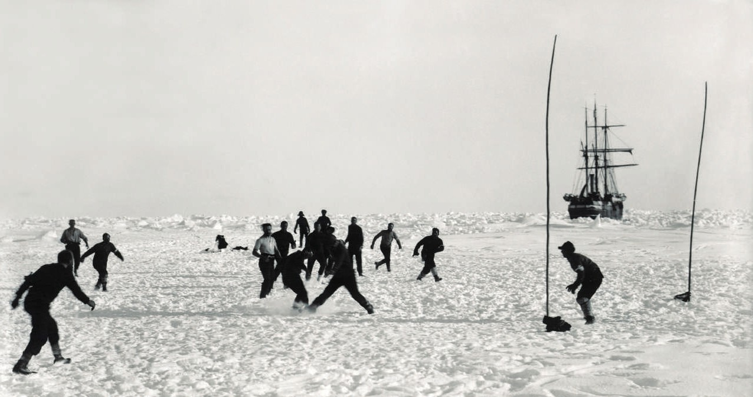
(not release) the ship.
The crew of the Endurance plays soccer to
pass the time. Their ship is in the background.
44 THE PAST
Copyright 2015 Cengage Learning. All Rights Reserved. May not be copied, scanned, or duplicated, in whole or in part. Due to electronic rights, some third party content may be suppressed from the eBook and/or eChapter(s).
Editorial review has deemed that any suppressed content does not materially affect the overall learning experience. Cengage Learning reserves the right to remove additional content at any time if subsequent rights restrictions require it.

    - Then one day, while some of the men (arrange) supplies on the ice, the ship (begin) to break up.
    - When the Endurance (start) to sink, Shackleton
(decide) to take his men across the ice on foot.

    - While Shackleton and five of his men (try) to reach the island of South Georgia to find help, the others (spend) several more months at the camp on the ice.
    - When Shackleton and his men (arrive) in Chile, they
(receive) a hero’s welcome.

APPLY.
  - Read Marta’s blog entry. Underline the past time clauses.

You won’t believe what happened to me tonight! While I was crossing Newton Street, a truck went through a red light. The driver was texting when the light changed. He wasn’t looking at the road. When I jumped out of the way, I fell onto the sidewalk and cut my knee. I was wearing my new jeans, too! When I got home, I took care of my knee and then called the police. Fortunately, I got the truck’s license number while I was lying in the street.


  - Work with a partner. Close your books and take turns retelling the story about Marta’s accident. Use past time clauses.
  - Think of an accident that you or someone you know had. Take notes in the chart. Use the questions to help you.

When did the accident happen?
Where were you?
What were you doing?
What happened?
What happened next?

  - In your notebook, write a paragraph about your accident. Use your notes from exercise C and Marta’s blog entry as a model. Use at least five past time clauses. When you are finished, read your story to a partner or small group.
UNIT 2 LESSON 3 45
Copyright 2015 Cengage Learning. All Rights Reserved. May not be copied, scanned, or duplicated, in whole or in part. Due to electronic rights, some third party content may be suppressed from the eBook and/or eChapter(s).
Editorial review has deemed that any suppressed content does not materially affect the overall learning experience. Cengage Learning reserves the right to remove additional content at any time if subsequent rights restrictions require it.

Repeated Past Actions: Used To and Would
LESSON 4

EXPLORE

CD1-13
- READ the conversation between two visitors to the British Museum in London, England. Notice the words in bold.
Who Owns the Past?
Cho: These statues are beautiful. Where are they from?
Noriko: They’re from Athens, Greece. I think they used to be a part of the Parthenon.
Cho: Well, it’s wonderful to see them, but why are they here in London? They should be back in Greece with the rest of the Parthenon.
Noriko: A lot of people agree with you. Lord Elgin, a British diplomat,1 brought these statues to London in the early nineteenth century.
Cho: You mean he just took them?
Noriko: Well, I don’t know. I’m not sure what really happened. Back then archaeologists2 used to do things like that. They would explore a historic site and bring objects from the site back to their home countries. Then, they would study them and put them on display in museums. Sometimes, that’s the only reason treasures like these survived.
Cho: But didn’t the Greek people try to stop Lord Elgin?
Noriko: Sure, there were a lot of complaints. Was it right or wrong to take these statues? It’s a difficult question. I love to visit museums and see things from around the world and learn about them.
Cho: Hmm . . . I understand what you’re saying, but
it still seems wrong to me, somehow. 1 diplomat: a person who acts as the
official representative of his or her
country in a foreign country
2 archaeologist: a person who studies the past by looking at items such as buried houses, tools, pots, etc.


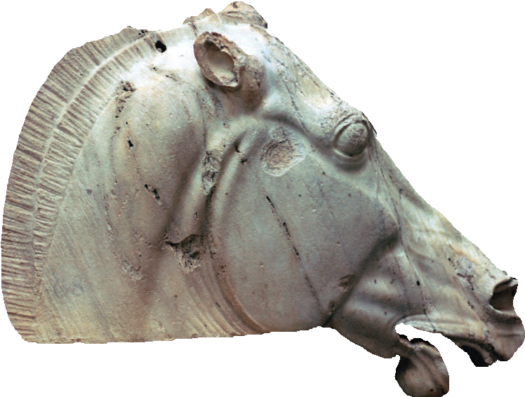
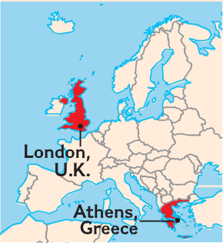

A statue of a horse’s head from the Parthenon,
Acropolis, Athens, Greece 447-432 B.C.

46 THE PAST

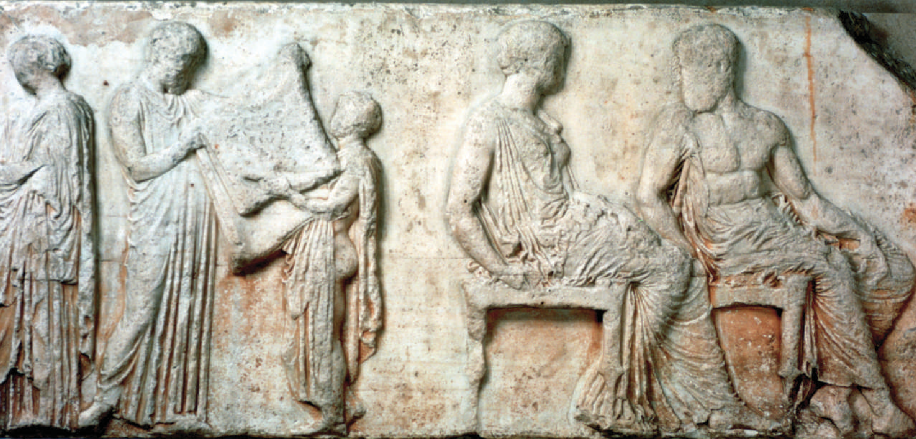

A carving from the Parthenon, Acropolis, Athens, Greece

- CHECK. Read the statements. Circle T for true or F for false.
  - The statues are from Italy. T F
  - The statues came to England in the 20th century. T F
  - Cho thinks the statues should go back to Greece. T F
  - In the past, it was not unusual for archaeologists to bring discoveries home. T F
  - Cho and Noriko agree about the future of the statues. T F

- DISCOVER. Complete the exercises to learn about the grammar in this lesson.
- Look at these sentences from the conversation in exercise 1. Decide whether the bold verb in each sentence refers to a single action (S) or a repeated action (R). Write S or R.
  - S Lord Elgin . . . brought these statues to London in the early nineteenth century.

  - You mean he just took them?

  - Back then archaeologists used to do things like that.

  - They would explore a historic site and bring objects from the site back to their home countries.
  - Then, they would study them and put them on display in museums.

- Look at the sentences from exercise A. Which verb forms are used for repeated actions?
Discuss your answer with your classmates and teacher.

UNIT 2 LESSON 4 47

LEARN
  - Used To: Affirmative and Negative Statements
Affirmative Negative
REAL ENGLISH
Use used to instead of the simple past to emphasize that the habit or state is not true now.
When I was young, I used to go to the beach every day.
Didn’t Use To Base Form
Subject
Used To Base Form
Subject

I/She/They used to study history. I/She/They didn’t use to study math.

    - Used to expresses a habit or state in the past that no longer exists.

    - In negative statements use use to, not used to.
I used to run several times a week. (Now, I don’t.) I used to live in a small town. (I live in a city now.) I didn’t use to eat meat. (I do now.)
I didn’t use to love math.

- Rewrite each sentence with used to or didn’t use to and the verb in bold.
  - Archaeologists removed objects from historic sites.

Archaeologists used to remove objects from historic sites.

  - I went to museums every weekend when I lived in Berlin.

  - My cousin lived across the street, but I didn’t see him much.

  - Jim didn’t like math when he was in school.

  - There was a supermarket near my home until last year.

  - Carole played in a band in college.

  - I didn’t drive much when I lived downtown.

  - Mike worked in a bank before he got his new job.

48 THE PAST

  - Used To: Questions and Answers
Yes/No Questions
Answers
Yes, he did. / No, he didn’t.
Yes, they did. / No, they didn’t.
Wh- Questions
Answers
In Mexico.
My friend, Felix.
Who or What as Subject
Answers
Professor Ortiz.
A shoe store.

- When a question includes did, use use to, not Did you use to live here?
used to. Where did she use to work?
- Remember: Who or What can take the place of ✓ Who used to live in that house? the subject in a Wh- question. ✗ Who use to live in that house?
Be careful! When Who or What is the subject of the question, use used to, not use to.

Did | Subject | Use To | Base Form
Did | he | use to | get | good grades?
 | they

Wh- Word | Did | Subject | Use To | Base Form
Where | did | she | use to | live?
Who |  | you |  | study | with?

Wh- Word | Used To | Base Form
Who | used to | teach | this class?
What |  | be | here?

- Complete each question with the words in parentheses. Use the correct form of used to.
  - Did you use to ride (you / ride) a bike when you were a child?

  - What (you / do) after school when you were a child?
  - (your family / live) in a different place?

  - Where (your mother / work)?

  - What (your family / do) on the weekends when you were a child?
  - Who (be) your English teacher?

  - (you / visit) your friends often?

  - Where (you / go) on vacation?

- SPEAK. Work with a partner. Ask and answer the questions from exercise 5.
REAL ENGLISH
When the phrases used to or use to are used to talk about the past, they are often pronounced /yusta/.
A: Did you use to ride a bike when you were a child?
B: Yes, I did.

UNIT 2 LESSON 4 49

Would: Repeated Past Actions
Affirmative and Negative Statements

- Would expresses a repeated past action or habit In high school, we would play soccer every that no longer exists. afternoon.
As a child, I wouldn’t study, but I would get good grades.
- Be careful! Do not use would for past situations ✓There used to be a library on this street. or states that no longer exist. Use used to or ✗ There would be a library on this street. use to. ✓He didn’t use to live on Palm Street.
✗ He wouldn’t live on Palm Street.

 | Subject | Would/ Would Not | Base Form
When I was in high school, | I | would ’d | ride | my bike to school.
When Scott was a child, | he | would not wouldn’t | eat | any vegetables.

- Complete each sentence. Use would and the verb in parentheses.
  - When I was a child, my father (take) me to the zoo about once a month.

  - In high school, my brother (not start) his homework until around midnight.
  - When Alicia was a child, she (play) with her friends after school.

  - When my parents were in school, they (eat) lunch at home every day.

  - In college, I often (not go) to bed until 3:00 a.m.

  - My grandfather used to work very hard during the week, but on the weekends he
(relax).

  - In college, Sandra (study) for about six hours every day.

  - When I was in high school, I (sit) in the back of the classroom and draw in my notebook.
  - When Kyle was on the soccer team, he (run) five miles every morning before school.
  - We (go) to the market every day when we lived in France.

50 THE PAST

PRACTICE


CD1-14
- Complete the article about the Iceman with the words and phrases from the chart. Use each word or phrase only once. Then listen and check your answers.

Used To | Would |  | Simple Past
used to hunt used to think | wouldn’t come would go | didn’t grow discovered | didn’t spend found | killed used

The Iceman
Back in 1991, hikers in the mountains near the border of Austria and Italy (1) discovered the body of a man in the ice. Scientists soon learned that the body was over 5000 years old. They called the man the “Iceman.”
Scientists (2) that the Iceman died from the cold. Five thousand years ago, people of central Europe (3) wild animals for food. They (4) up into the mountains in all kinds of weather, and sometimes they (5) back. Then, in 2001, scientists found part of an arrow in the Iceman’s body. Somebody (6) the Iceman, and we will probably never know why.
After more recent tests, scientists now think the Iceman was not just a hunter. They think he probably had a higher position in society, and (7) a lot of time in the mountains. Before the most recent tests, scientists believed that people in the Iceman’s community (8) crops.1 However, they
(9) small pieces of stone in the Iceman’s stomach. This suggests that the Iceman’s people (10) stones to grind2 flour for some kind of bread.
Even though the Iceman died over 5000 years ago, we know a lot about his life thanks to scientific research.

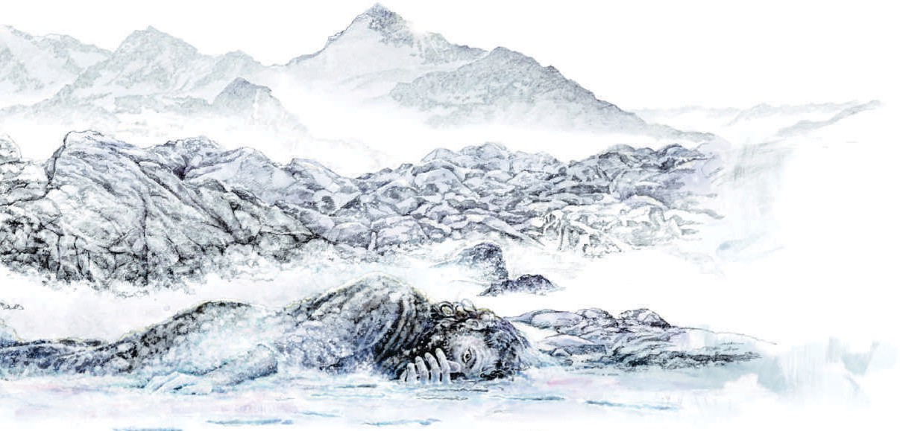

1 crops: plants that people grow for food
2 grind: to rub something until it becomes a powder

How the Iceman died used to be a mystery. Now scientists think they have the answer.

UNIT 2 LESSON 4 51
Copyright 2015 Cengage Learning. All Rights Reserved. May not be copied, scanned, or duplicated, in whole or in part. Due to electronic rights, some third party content may be suppressed from the eBook and/or eChapter(s).
Editorial review has deemed that any suppressed content does not materially affect the overall learning experience. Cengage Learning reserves the right to remove additional content at any time if subsequent rights restrictions require it.

- WRITE. Look at the information in the chart about people 5000 years ago and people today. Then write six sentences using used to, didn’t use to, or would.

People 5000 Years Ago People Today
hunt animals, gather fruit and nuts cook over fire  live in caves or simple shelters use animal skins for clothing | buy food in grocery stores cook with stoves  live in houses or apartments  buy clothing in stores or make clothing from cloth

People didn’t use to buy food in a grocery store.
1.

2.

3.

4.

5.

6.

APPLY.
- A few years ago Brian was not happy, so he made some changes. Look at the chart. What changes did he make? Discuss them with a partner.
Brian used to be unhappy, and he didn’t have many friends. He joined a band last year. Now . . .

Brian
In the Past | Change | Now
lonely, didn’t have many friends | joined a band last year | happy, has new friends
unhealthy | bought a bike a few months ago | healthy
always arrived late for class and work | learned to drive last month | always arrives on time

- Think about some changes you have made in your life. In your notebook, make a chart like the one in exercise A and write notes about three of these changes.
- Work with a partner. Take turns talking about the changes in your life. Use used to, didn’t use to, and would.
- In your notebook, write a short paragraph of four or five sentences about one of the changes you made.

A couple of years ago, I used to feel lonely all the time. I would stay home at night and watch TV . . .

52 THE PAST
Copyright 2015 Cengage Learning. All Rights Reserved. May not be copied, scanned, or duplicated, in whole or in part. Due to electronic rights, some third party content may be suppressed from the eBook and/or eChapter(s).
Editorial review has deemed that any suppressed content does not materially affect the overall learning experience. Cengage Learning reserves the right to remove additional content at any time if subsequent rights restrictions require it.

Charts 2.1–2.9
UNIT 2 Review the Grammar

Charts 2.1–2.7
- Circle the correct word(s) or phrase(s) to complete each sentence.
  - Hundreds of years ago, people used to believe / would believe that the Earth was flat.

  - My brother put / was putting the phone down while I talked / was talking to him.

  - When the plane landed / was landing safely, everyone started / was starting to clap.

  - When my grandfather was young, he was walking / would walk five miles to school every day.

  - How many reports did Malik write / did Malik use to write last week?

  - Lisa used to live / would live in Miami, but then she moved / was moving to Paris.

  - Were you going / Did you use to go to Central Park a lot when you were living / would live
in New York?

  - Yuri drove / was driving home when his car broke down / was breaking down.

  - I wanted / used to want to see the show, but I couldn’t get a ticket.

  - Did you use to play / Were you playing tennis when you hurt / were hurting your arm?

- Complete each sentence or question with the word(s) in parentheses. Use the simple past, the past progressive, or used to. There is more than one correct answer for some items.
  - While I was siting (sit) in the airport lounge, I saw (see) a famous actor.
  - Irina (write) poems, but now she writes short stories instead.

  - Martin (try) to turn on his computer, but nothing
(happen).

  - When my brother and I (be) young, we
(play) games with my parents in the evenings.

  - (you / have) trouble with the alphabet when you
(learn) Arabic?

  - We (go) to the movies three times last week.

  - I (work) when you (call), so I (not answer) the phone.
  - When Stephanie was a child, she (visit) her grandparents twice a month.

UNIT 2 REVIEW THE GRAMMAR 53
Copyright 2015 Cengage Learning. All Rights Reserved. May not be copied, scanned, or duplicated, in whole or in part. Due to electronic rights, some third party content may be suppressed from the eBook and/or eChapter(s).
Editorial review has deemed that any suppressed content does not materially affect the overall learning experience. Cengage Learning reserves the right to remove additional content at any time if subsequent rights restrictions require it.

Charts 2.1, 2.3,
Review the Grammar UNIT 2
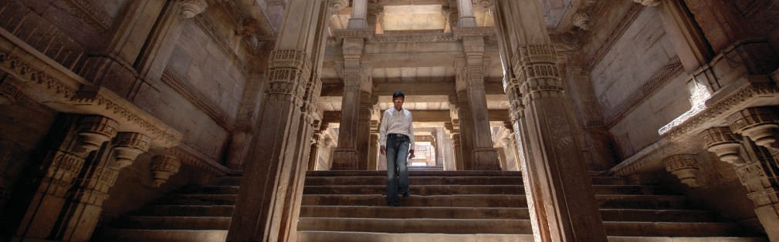
2.5, 2.9
- EDIT. Read the paragraph about stepped wells in India. Find and correct six more errors with the simple past, the past progressive, and would.

Stepped Wells in India
Northern India is very hot. The area gets a lot of rain, but the water disappears very quickly

began
because of the heat. Around 1500 years ago, the people of northern India used to begin to
build stepped wells to provide water for the population. They dug deep holes to reach water underground, and they were making rock walls for the wells. In each well, they builded stone steps and passages to help people reach the water easily. They often were decorating the walls of the passages with beautiful designs.
The stepped wells were long and narrow. They were cool, dark places, and they were often having special rooms away from the heat. While people were collecting water, they would took some time out of their busy days and talk with their neighbors. The wells becomed important social centers.

A visitor walks into a stepped well in northern India.

Charts 2.1, 2.3,
2.5

CD1-15

LISTEN & WRITE.
- Look at the photos on page 55. Then listen to the stories of four people who survived attacks by wild animals. Complete the chart with information about each person’s story.
 | Eric Nerhus | Ben Nyaumbe | Kootoo Shaw | James Morrow
Activity | diving
Animal |  |  | polar bear
Place |  | Kenya
Reason for Survival |  |  |  | his face mask protected him

54 THE PAST
Copyright 2015 Cengage Learning. All Rights Reserved. May not be copied, scanned, or duplicated, in whole or in part. Due to electronic rights, some third party content may be suppressed from the eBook and/or eChapter(s).
Editorial review has deemed that any suppressed content does not materially affect the overall learning experience. Cengage Learning reserves the right to remove additional content at any time if subsequent rights restrictions require it.

an alligator a python

a shark a polar bear

CD1-15
- Write sentences about each story from exercise A. Use the information in the chart, the simple past, the past progressive, and past time clauses. Then listen again and check your sentences.

While Eric Nerhus was diving in Australia, a shark atacked him. He survived because the shark bit his belt.

Charts 2.1–2.6

SPEAK.
- Think of a dangerous situation that you or someone you know was in. What happened? What did you or this person do? How did you or this person survive? Write notes in your notebook.

- Work with a partner. Take turns telling your stories from exercise A. Use the simple past, the past progressive, and past time clauses. Ask your partner questions for more information about his or her story.


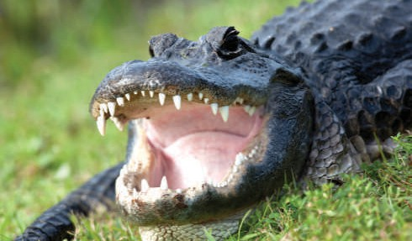




UNIT 2 REVIEW THE GRAMMAR 55
Copyright 2015 Cengage Learning. All Rights Reserved. May not be copied, scanned, or duplicated, in whole or in part. Due to electronic rights, some third party content may be suppressed from the eBook and/or eChapter(s).
Editorial review has deemed that any suppressed content does not materially affect the overall learning experience. Cengage Learning reserves the right to remove additional content at any time if subsequent rights restrictions require it.

READ & NOTICE THE GRAMMAR.
Connect the Grammar to Writing
    - Read the story. What difficult experience did the writer have? How did she survive? Discuss the writer’s experience with a partner.

A flooded river in York, England

Remembering a Spring Flood
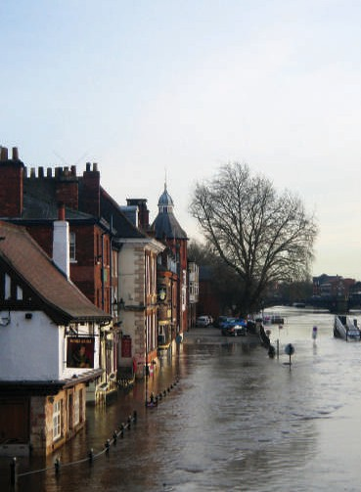
When I was a young girl, we lived near a river.
GRAMMAR FOCUS
In the story, the writer uses the simple past to talk about completed actions and events.
I looked out my window.
My parents came and got me.
The writer uses the past progressive to describe a scene in the past.
The river was rising very quickly.
The writer uses past time clauses to describe when actions or events happened.
When I was a young girl, we lived near a river.
Every spring when the snow melted, it caused the river to rise a few feet. Then the level of the river would fall again. One spring, however, the river kept rising.
One day that spring, I looked out my window.
The river was rising very quickly. My parents came and got me. While the water was rising higher, we climbed onto the roof of our house. From the roof, I looked down at the river. It was covering everything in its path. My family and I waited on our roof for help. I was losing hope when we were finally rescued.

    - Read the story from exercise A again. Circle the simple past, underline the past progressive, and double underline the past time clauses. Then work with a partner and compare your answers.

    - Complete the chart with information from the story in exercise A. Add more boxes to the chart if necessary.

Event 1 | Event 2 | Event 3 | Event 4
One spring, the My parents
river near my came and got house kept rising. me.

56 THE PAST
Copyright 2015 Cengage Learning. All Rights Reserved. May not be copied, scanned, or duplicated, in whole or in part. Due to electronic rights, some third party content may be suppressed from the eBook and/or eChapter(s).
Editorial review has deemed that any suppressed content does not materially affect the overall learning experience. Cengage Learning reserves the right to remove additional content at any time if subsequent rights restrictions require it.

Write about a Difficult Experience
WRITING FOCUS
Identifying and Correcting Sentence Fragments
A sentence fragment is missing an important part of a sentence, such as a subject or verb.
- My family and I waited on our roof for help.
✗ Waited on our roof for help. (no subject)
- It was covering everything in its path.
✗ Everything in its path. (no subject and no verb)
Make sure each of your sentences has a subject and a verb.

BEFORE YOU WRITE.
    - Brainstorm a list of difficult experiences you have had.

    - Choose one experience to write about. Use the chart below to describe your experience.
Add more boxes to your chart if necessary.

Event 1 | Event 2 | Event 3 | Event 4

  - WRITE about your difficult experience. Use the information from your chart from exercise 2B
and the story from exercise 1A to help you.

  - SELF ASSESS. Read your story and underline the simple past, the past progressive, and past time clauses. Then use the checklist to assess your work.
 I used the simple past to talk about completed actions and events. [2.1]  I used the past progressive to describe a scene in the past. [2.3]
 I used past time clauses to tell when an action or event happened. [2.5, 2.6]  I checked for and corrected sentence fragments. [WRITING FOCUS]

UNIT 2 CONNECT THE GRAMMAR TO WRITING 57
Copyright 2015 Cengage Learning. All Rights Reserved. May not be copied, scanned, or duplicated, in whole or in part. Due to electronic rights, some third party content may be suppressed from the eBook and/or eChapter(s).
Editorial review has deemed that any suppressed content does not materially affect the overall learning experience. Cengage Learning reserves the right to remove additional content at any time if subsequent rights restrictions require it.

